Commodore CBM8296 Diagnostic: Cassette Dongle Rev. 0  
Module Description

# Introduction

This Cassette Dongle is part of the diagnostic clip set for the Commodore CBM8296. The original Commodore part number is 324804-01. The feedback signals are directly wired to an edge connector. This Cassette Dongle is based on a PCB.

The diagnostic setup requires **two cassette dongles**.

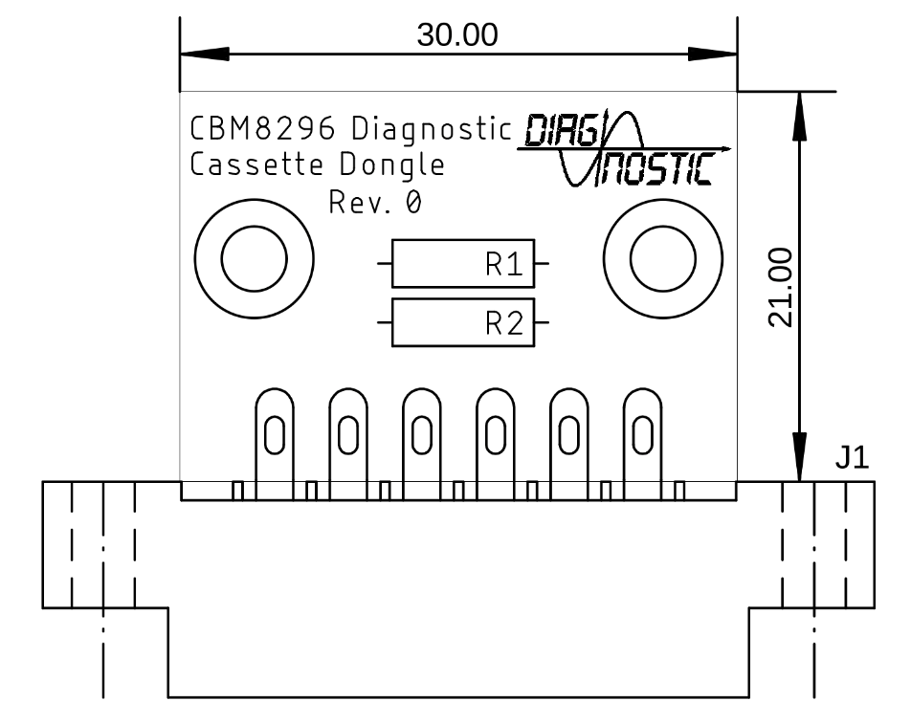

Figure 1: Dimensions of the Cassette Dongle

# Soldering The Edge Connector

To provide a defined position of the edge connector, it is recommended to solder it flat on the bottom side of the PCB. Then bending the top solder latches towards the board on the top side, so that a part lays flat. A suitable tool for this is a screw driver or tweezers. Finally soldering the latches to the top solder pads while holding them down until the solder joint has cooled down. It is best to do this before any through hole component is installed.

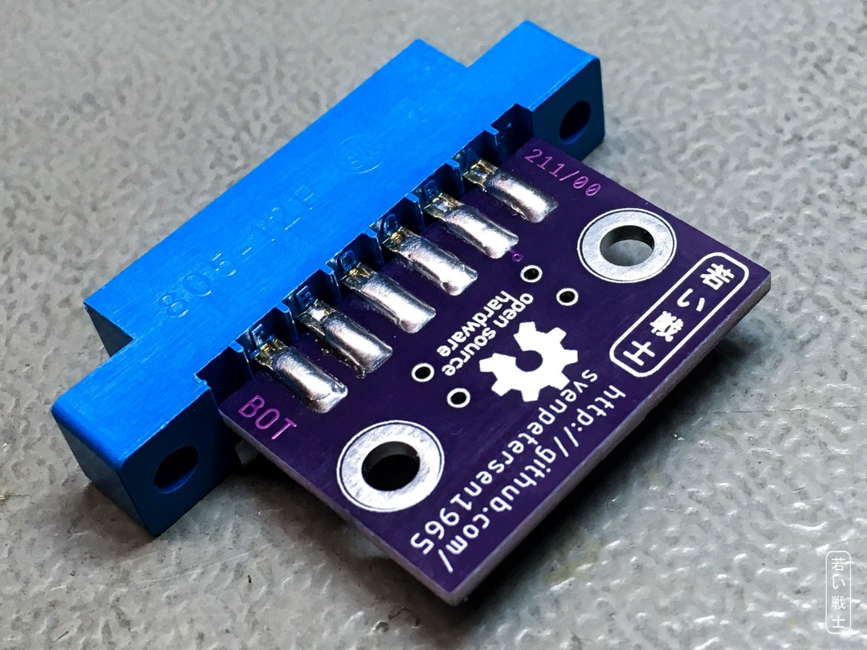

Figure 2: Step 1: Solder the bottom latches flat on the bottom side of the PCB

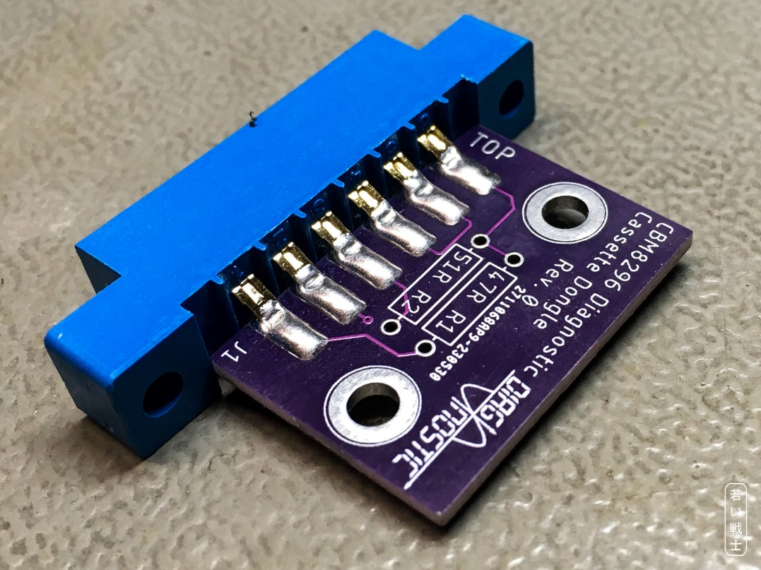

Figure 3: Step 2 and 3: The top latches are bent and solder to the solder pads on the top side

# 3D-printed Case

The STL-files of the case are provided in the respective sub-folder of this project as is the label print.

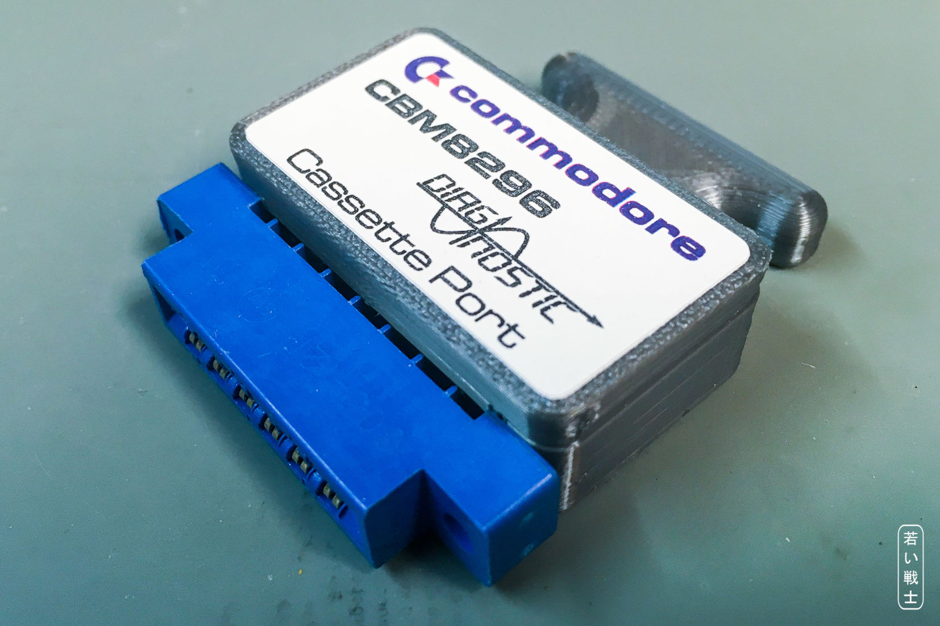

Figure 4: CBM8296 User Port dongle in a 3D printed case with label

Recommended screws: 2 each of C2.9x9.5 self-tapping screws for sheet metal (C 2,9x9,5H, DIN 7981).

# Connections

|  |  |
| --- | --- |
| Connection | Signals |
| 1 - (47Ω) - 6 | GND - SENSE |
| 3 – (51Ω) - 6 | MOTOR - SENSE |
| 4 - 5 | READ – WRITE |

R1 and R2 serve as a voltage divider for the motor voltage (appr. 6V).

# Revision History

## Rev. 0

* Prototype, not yet tested.